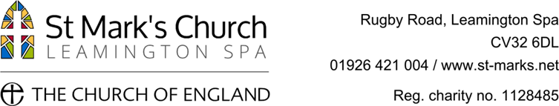 | Application Form

Candidates are requested to complete the form and email or send it to the church office. The details are at the end of the form.

1. | Personal Details
 | Last Name / Family Name: |  |  |  |  |  |  | First Name(s): |  |  |  |  |  |  | Title:
 | Address:
 |  |  |  |  |  |  |  |  |  |  |  | Post Code:
 | Telephone Numbers: |  |  | Daytime: |  |  |  |  |  | Evening:
 | Mobile: |  |  |  |  |  | Email Address:

2. | Present or Most Recent Employment
 | Employer’s Name:
 | Employer’s Address:
 |  |  |  |  |  |  |  | Post Code:
 | Post Title:
 | Dates of Appointment: | From: |  |  |  | To: | Present, or
 |  |  |  |  |  |  | Date:
Main Responsibilities:

(no not overrun the page boundary; continue on a separate sheet if necessary)
 | Period of Notice Required: |  |  |  | Salary Wage: £ |  |  | Full-Time:  Part-Time:
 | If unemployed, then please give a brief outline of your current situation / occupation (including any voluntary work):

3. | Previous Employment (Please start with the most recent. Include paid / unpaid / voluntary work.)
 | Dates of Appointment:  From To |  | Employer’s Name | Post Held, with Brief Outline of Main Responsibilities: | Salary /  Wage: | Reason for  Change:
 |  |  |  |  | N/n | .

4. | General & Further Education
 | School / College / University / Professional Body: | Qualifications Obtained: | Grades / Levels: | Date Obtained

5. | References
Please give the names of two people who could provide a reference regarding your suitability for this post.
One of these should be your Present or Most Recent Employer. You should not give friends or relatives as referees.

 | Name:
 | Job Title / Position:
 | Address:
 | Post Code:
 | Tel. No:
 | Email Address:
 | May we request a reference prior to interview? | Yes |  | No |  | Yes |  | No

6. | Supporting Information
 | Please outline how your knowledge, skills and experience meet the criteria in the person specification and the tasks required in the role.
7. Are you a British subject or a national of any EU country? Yes No

If no do you have the right to work in the UK and a current work permit? Yes No

If yes, please state expiry date ___________________

8. | Criminal Convictions and Cautions
Have you ever been convicted of a criminal offence? Yes No
If yes or you have any criminal proceedings pending against you, then please give full details as a separate document, clearly stating your full name and marked ‘Private and Confidential’.

8. | Data Protection Act 2018
 | The information that you provide is subject to the protection of the Data Protection Act 2018, and will not be used for any alternative purpose without your consent.

9. | Declaration
To the best of my knowledge and belief, the information contained in this form is accurate. I understand that giving false information, or failure to supply details, will invalidate an offer of employment, or lead to termination of employment.
I agree to this information being used for legitimate purposes connected with recruitment and selection monitoring.
Please note that, in submitting this form, you have accepted these terms, and agree to this declaration.

 | Signed: (type your name if emailing this form) |  | Date:

10. | Return the Completed Form
 | Please return the completed form by email to office@st-marks.net or send it to The Church Office, St Mark’s Church, Rugby Road, Leamington Spa, CV32 6DL.

