GUIDELINES FOR CAKE-MAKERS 2023
Thank you for offering to make a cake, to keep people as safe as possible, please follow the steps below:
- Pets must be removed from your kitchen during preparation, baking and handling of your cake.
- Please make your cake as near as you can to the time of serving, or freeze it as soon as possible after making and defrost just before the function.
- We may not be able to accept cakes with fresh cream or anything which needs to be kept in the fridge – please check with the event organiser.
- Ideally bring your cake on a disposable plate. It must be covered. If you need to bring it in a tin or on a china plate please label it with your name and note that St Mark’s cannot be responsible for any lost or damaged items.
- Complete the record sheet below and hand it in with your cake.
*The following foods are all considered to be allergens: cereals containing gluten (wheat incl. spelt, rye, barley and oats), eggs, milk, nuts, peanuts, sesame seeds, lupin and soya.
Description of cake | Made by | Date made/ defrosted | Has it been frozen  (y/n) | Does it contain  any of these: | 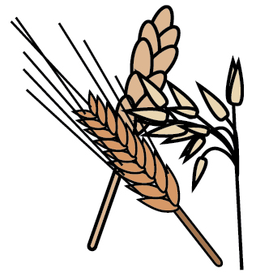 | 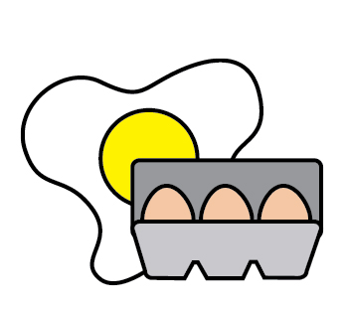 | 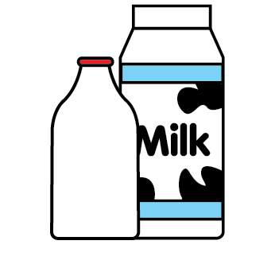 | 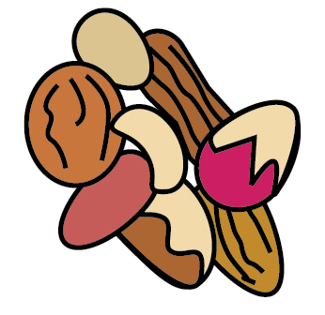 | 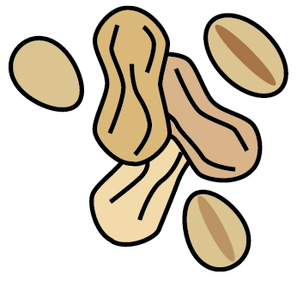 | 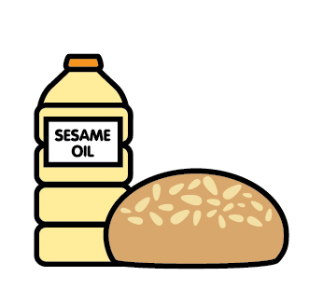 | 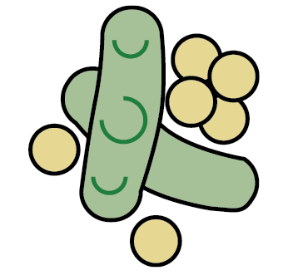
 |  |  |  |  | Cereals containing gluten | Eggs | Milk | Nuts | Peanuts | Sesame seeds | Soya

